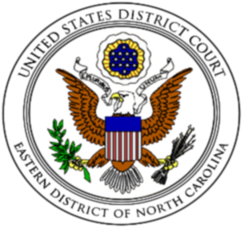  Phone: (919) 645-1700  Fax: (919) 645-1750 | United States District Court  Eastern District of North Carolina  Office of the Clerk  Post Office Box 25670  Raleigh, North Carolina 27611 | Peter A. Moore, Jr.  Clerk of Court

Instructions for Request for Exception from Training under
Local Civil Rule 83.10 and/or Local Criminal Rule 24.1(c)

Local Civil Rule 83.10 and Local Criminal Rule 24.1(c) both provide that if a party has a need to use any type of courtroom technology, counsel must notify the case manager and request training from the court’s information technology staff for the person or persons who will be operating the courtroom technology. Those rules further provide that unless excepted by the clerk, counsel must file a certification of training no later than 7 days before the scheduled proceeding.

To be eligible for an exception by the clerk, counsel must complete the attached form, certifying that the person(s) who will be operating the courtroom technology received training from the court’s information technology staff within the past year. Counsel must specify the case number in which the prior certification of training was filed, as well as the filing date and docket entry number of the prior certification. Counsel must then file the completed form for it to be considered by the clerk, using the “Request for Courtroom Technology Exception” event.

IN THE UNITED STATES DISTRICT COURT
FOR THE EASTERN DISTRICT OF NORTH CAROLINA
Choose an item. DIVISION
No. Enter case number

Enter party name  v.  Enter party name | )))))))  )  ) | Request for Exception From Training For Use of Courtroom Technology
The undersigned requests an exception from Select one:.
The undersigned certifies that the person(s) responsible for operating courtroom technology for the Select one: in this action received training from the court within the past year, and a Certification of Training for Use of Courtroom Technology was filed in Case No. enter case number on Click here to enter a date. at docket entry number enter docket entry number . The undersigned understands that the court and its employees do not provide information technology services.

Enter signature and signature block as required by Local Civil Rule 10.1 and Local Criminal Rule 47.3

Certificate of Service
I hereby certify that I have served a copy of Notice of Certification of Training for Use of Courtroom Technology on Click here to enter a date. by insert method of serviceon the following:
Insert name of attorneys and any party who appears pro se.

Enter your signature and signature block

